Features With Screenshots:

Snow Weather Effect:

In each of the screenshots you will be able to see snow particles on the screen. Each of the snow particles is created using a particle system which is moves with the camera and rotates in the opposite direction to the camera to reduce the total number of particles needed while making it seem to exist across the whole scene.

To make this effect seem more real I have also added an effect where the snow appears to melt and build up which is displayed best in other features.

Orbs:

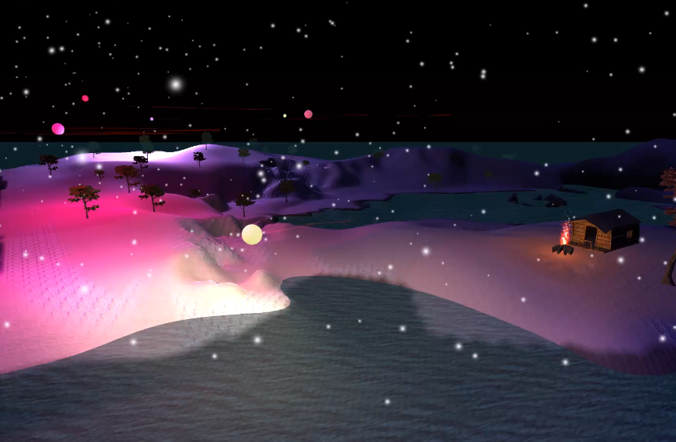

These Orbs are mysterious lights in the sky which rotate in relation to their parent objects. There are large Orbs that orbit around a specific position and smaller orbs which orbit around the larger orbs. The orbs follow a path a large loop with smaller loops within the loop. Each of the orbs has a light component attached to light up the surroundings which is matched by the colour of the orb, I have written a shader for the orbs to give the visual appearance of the orb emitting light. Each orb has a trail which is made using the fire shader I used for the campfire and meteor impact.

Meteor Impact causing permanent change to planet surface and some snow buildup:

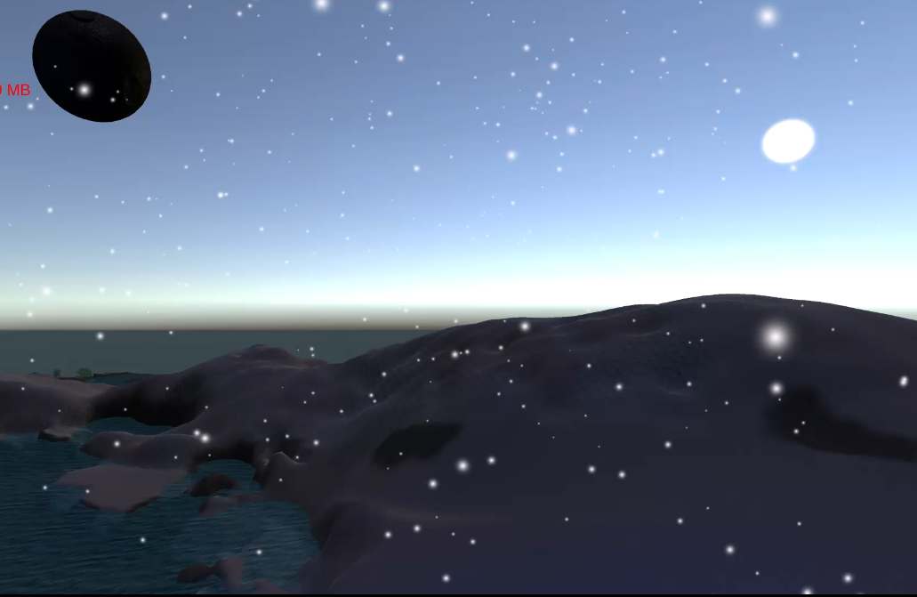

The Meteor is travels towards a specific position in the mountain while spinning.

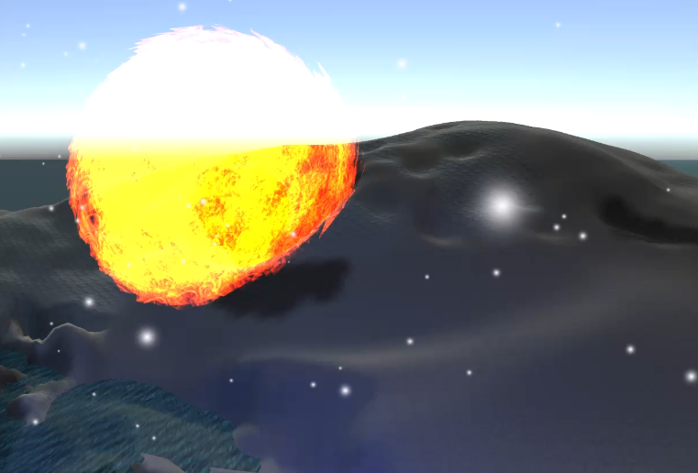

Upon impact a particle system is used to send out the fire material (which is also used for campfires and orb trail) which is made using a custom shader in all directions in one large burst.

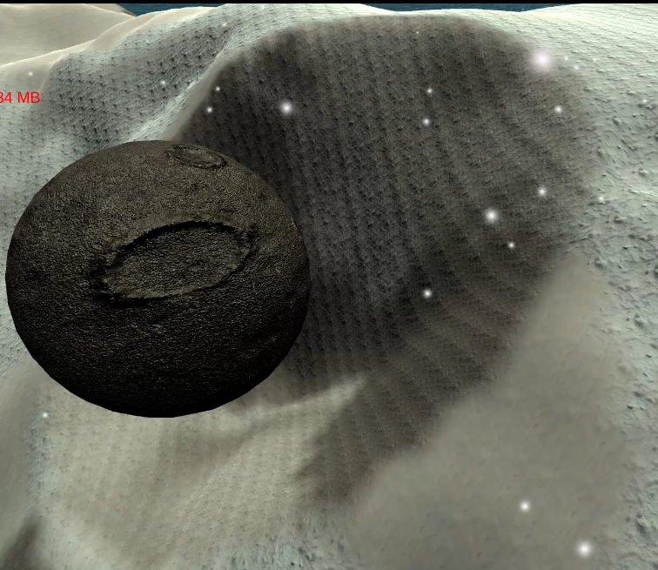

After impact the terrain is damaged leaving a crater and the snow texture on the ground is replaced with a more rocky texture to give the effect of the rock being uncovered after the impact.

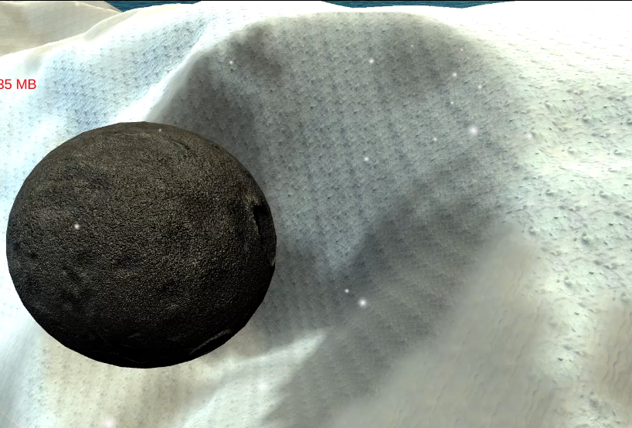

After some time has passed the rock texture is slowly covered by the snow rock texture and the snow texture to give the effect of snow build up over time.

Day/Night Cycle and Lighting Changes:

Scene At Night

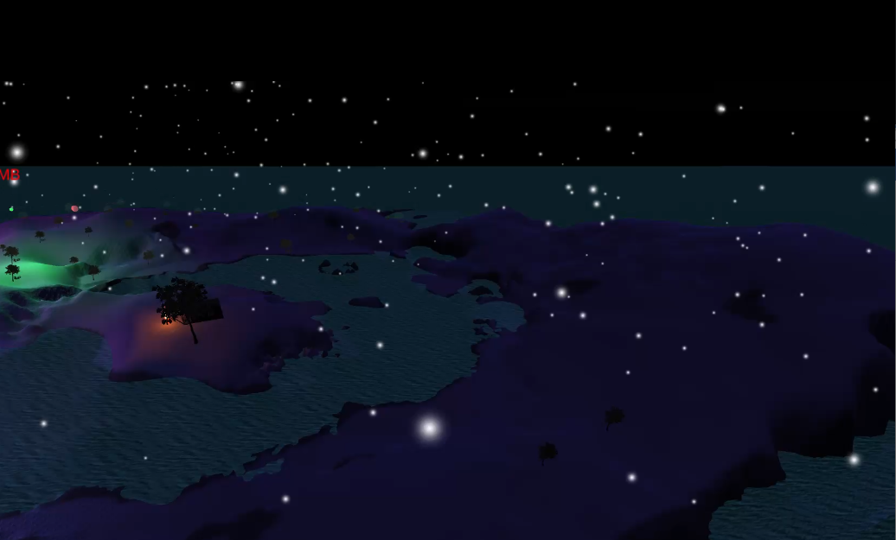

Scene during the Day

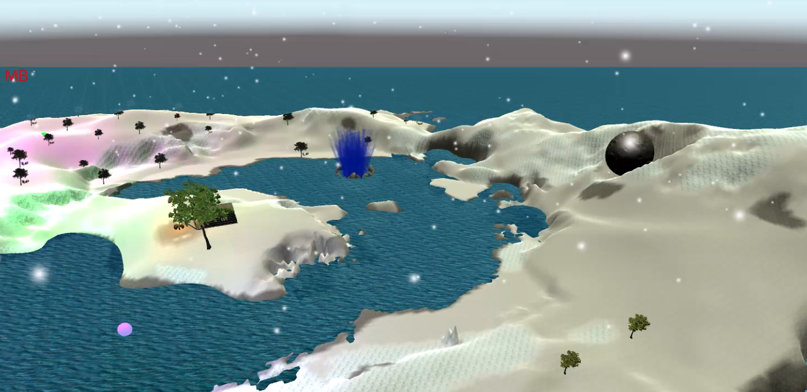

I have introduced a day/night cycle where the intensity, colour and direction of the sunlight changes depending on the time of day. I have a main light to represent the sun and a second ambient light to light up the scene during the night. Each of the intensities of these change in relation to the time of day and the colour of these lights change depending on the intensity of the light using a Colour gradient. Additionally the colour of the water and the light reflections on the water change depending on the time of day (see the water section). There some of the other features help to enhance the day night cycle e.g. orbs and campfire.

Water with reflection and waves:

The Water is made with a custom water shader which creates waves across the water surface, gradually raises and lowers the height of the vertexes to make it seem as if there is a tide, changes colour depending on the ambient and sunlight and is semi-transparent. The waves on the surface of the water are made by using a normal texture and sin waves to make waves appear across the surface of the water along the normals of the x and y axis of the screen. The height of the vertexes are changed by sampling from a Perlin noise texture to make the water seem more uneven. The colour of the water changes alongside the day night cycle by including the ambient light in the final colour calculation which makes the water darker or lighter depending on the colour of the ambient light during that point in the day.

Water during the night matches the darker ambient light

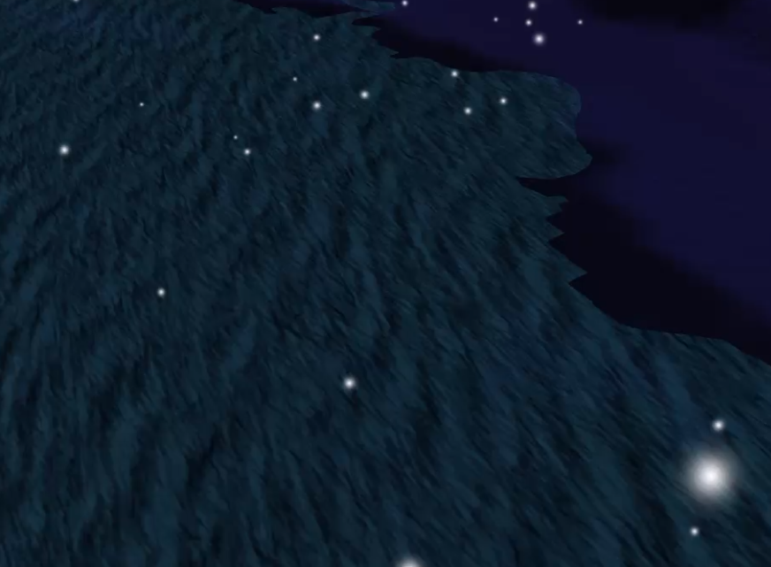

Water during the day matches brighter ambient light and Sunlight

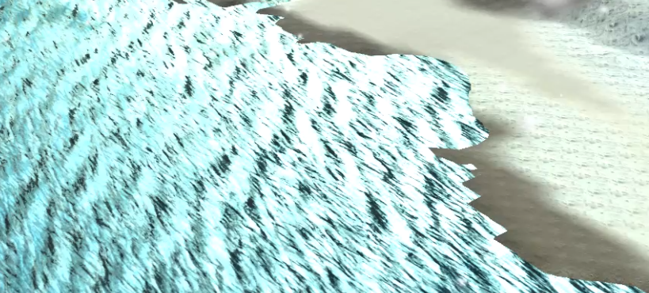

Light Reflection on water using similar method to Phong Reflection Model only based on the normal and direction due to sunlight not having proper distance away from surface so no attenuation but still keeping specular. Water darker where not reflecting light

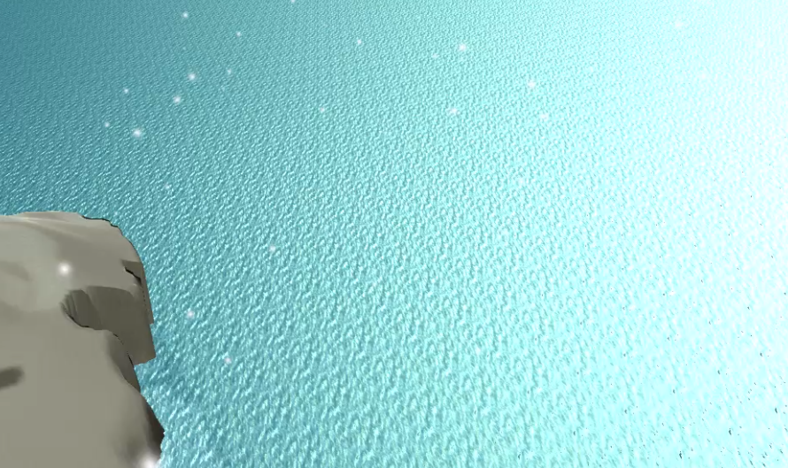

Campfire with snow melting:

Campfire at the start of the scene

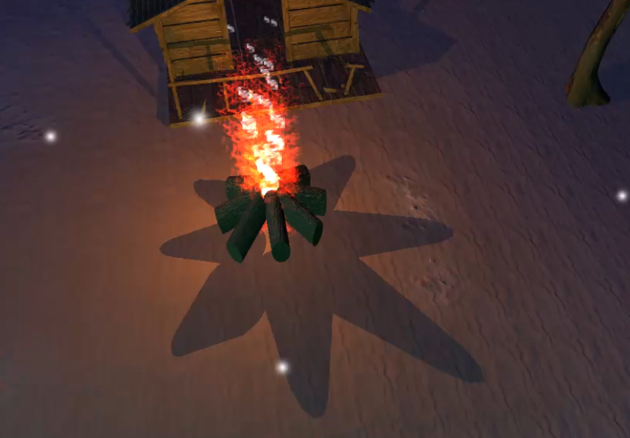

Campfire after the snow has melted but the ice rock hasn’t quite melted yet

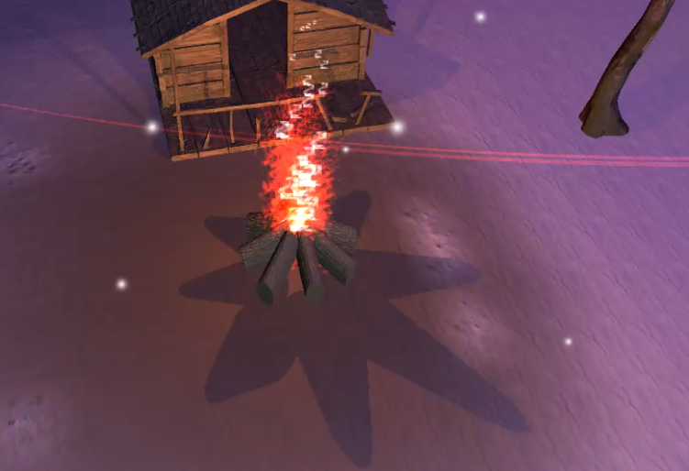

Comprised of two particle systems one for smoke and one for the fire. Each system uses a custom material with a custom shader for its particles a smoke material with a smoke shader and a fire material with a fire shader. The fire also emits a light which has a flickering effect by changing the intensity. The fire also has an effect where the snow around it appears to melt in a certain radius around the fire, where the snow and ice rock are gradually replaced with a rock texture. To make this effect seem more real I have also made the ice rock texture be replaced at a slower rate than the snow texture.

Geyser:

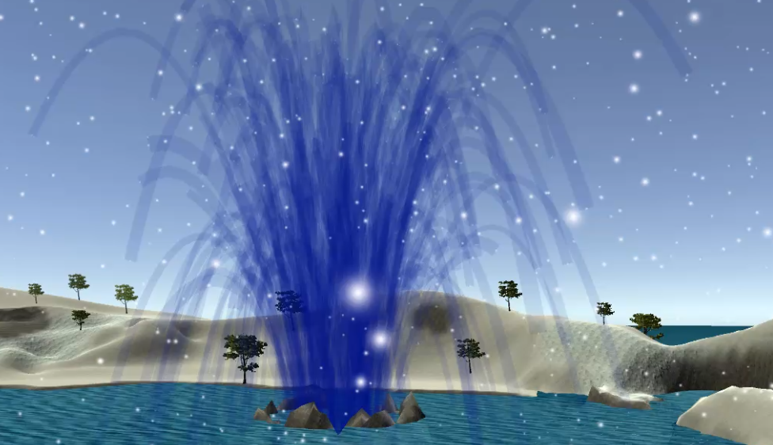

The Geyser is made using a particle system which erupts at a given frequency. The particle system outputs a constant stream of particles which are effected by gravity and then the particles are given a trail to appear like water flowing out. Occasionally, there will be short larger bursts of particles to help give the effect of it erupting with at the beginning there being the two largest bursts. Additionally, as the particle travels the alpha of the trail is reduced to make it appear as if the water stream is slowly ending.

The trail particles use a custom shader which is essentially a more simple version of my water shader where I have only included ambient light as a factor in colour change and the base colour is taken from the particle system itself.

Youtube Video Link:

<https://www.youtube.com/watch?v=8iEzwsZvgdI>

Textures/Assets Used:

Perlin Noise texture (Used for water) randomly generated using this tool: <http://kitfox.com/projects/perlinNoiseMaker/>

Water Texture and normal map taken from: <https://www.cadhatch.com/seamless-water-textures>

Snow Drift PBR Material taken from: <https://freepbr.com/materials/snow-drift/>

Rock Snow and Ice PBR Material taken from: <https://freepbr.com/materials/rocky-snow-ice/>

Rocky Dirt PBR Material taken from: <https://freepbr.com/materials/rocky-dirt/>

Light Tree Bark PBR Material taken from: <https://freepbr.com/materials/light-tree-bark/>

Asteroid or Planetary Rock Ground Texture (Ground 0010) taken from: <https://www.texturecan.com/details/136/>

Realistic Tree 9 [Rainbow Tree] by Pixel Games taken from: <https://assetstore.unity.com/packages/3d/vegetation/trees/realistic-tree-9-rainbow-tree-54622>

Cabin Environment by Gregory Seguru taken from: <https://assetstore.unity.com/packages/3d/environments/cabin-environment-98014>

Fire image by Cullan Smith taken from: <https://unsplash.com/photos/red-fire-digital-wallpaper-BdTtvBRhOng>

Smoke image by Pascal Meier taken from: <https://unsplash.com/photos/white-smoke-1uVCTVSn-2o>